***LAB MANUAL***

***For***

***Computer Graphics***

***Laboratory***

**2020 -2021**

**BTech 4thrd Sem**

*Dr. Dhananjoy Bhakta (CSE)*



**भारतीय सूचना प्रौद्योगिकी संस्थान राँची**

**INDIAN INSTITUTE OF INFORMATION TECHNOLOGY, RANCHI**

(An Institution of National importance under act of Parliament)

(Ranchi - 834010), Jharkhand

***Department of Computer Science and Engineering***

***IN­­DEX***

|  |  |  |
| --- | --- | --- |
| **Sr. No.** | **Experiment** | **Date** |
| 1 | *DDA Algorithm* |  |
| 2 | *Bresenham Line Algorithm* |  |
| *3* | *Midpoint Circle Algorithm* |  |
| *4* | *Bresenham Circle Algorithm* |  |
| *5* | *Midpoint Eclipse Algorithm* |  |
| *6* | *Stylish Text and Filling Algorithms* |  |
| *7* | *Basic 2D Transformation* |  |
| *8* | *Drawing a Car* |  |
| *9* | *Polygon Clipping using Sutherland - Hodgeman Algorithm* |  |
| *10* | *Line Clipping using Cohen - Sutherland Algorithm.* |  |
| *11* | *Basic 3D Transformation* |  |

***By Prithwiraj Samanta(2018UGCS002R)***

***EXPERIMENT NO.1***

**Aim**

Draw a line using DDA algorithm.

**Theory**

A linear DDA starts by calculating the smaller of dy or dx for a unit increment of the other. A line is then sampled at unit intervals in one coordinate and corresponding integer values nearest the line path are determined for the other coordinate.

Considering a line with positive slope, if the slope is less than or equal to 1, we sample at unit x intervals (dx=1) and compute successive y values as

{\displaystyle y_{k+1}=y_{k}+m}{\displaystyle x_{k+1}=x_{k}+1}Subscript k takes integer values starting from 0, for the 1st point and increases by 1 until endpoint is reached. y value is rounded off to nearest integer to correspond to a screen pixel.

For lines with slope greater than 1, we reverse the role of x and y i.e. we sample at dy=1 and calculate consecutive x values as

{\displaystyle x_{k+1}=x_{k}+{\frac {1}{m}}}{\displaystyle y_{k+1}=y_{k}+1}Similar calculations are carried out to determine pixel positions along a line with negative slope. Thus, if the absolute value of the slope is less than 1, we set dx=1 if {\displaystyle x_{\rm {start}}<x_{\rm {end}}}i.e. the starting extreme point is at the left.

**Program**

#include<bits/stdc++.h>

#include<graphics.h>

#define ll long long int

using namespace std;

int main()

{

int gd = DETECT, gm, tmp = 0;

ll x1 = 0, x2 = 0, y1 = 0, y2 = 0, dx = 0, dy = 0;

ll steps = 0, xinc = 0, yinc = 0, x = 0, y = 0;

cin >> x1 >> y1;

cin >> x2 >> y2;

dx = x2 - x1;

dy = y2 - y1;

if(abs(dx) > abs(dy)) steps = abs(dx);

else steps = abs(dy);

xinc = dx / steps;

yinc = dy / steps;

x += xinc;

y += yinc;

//declare all variables before it

initgraph(&gd,&gm, NULL);

//draw here

for(ll i = 0; i < steps; i++)

{

x += xinc;

y += yinc;

putpixel(100 + x, 100 + y, 15);

delay(300);

}

//draw ends

getche();

closegraph();

return 0;

}

**Output**

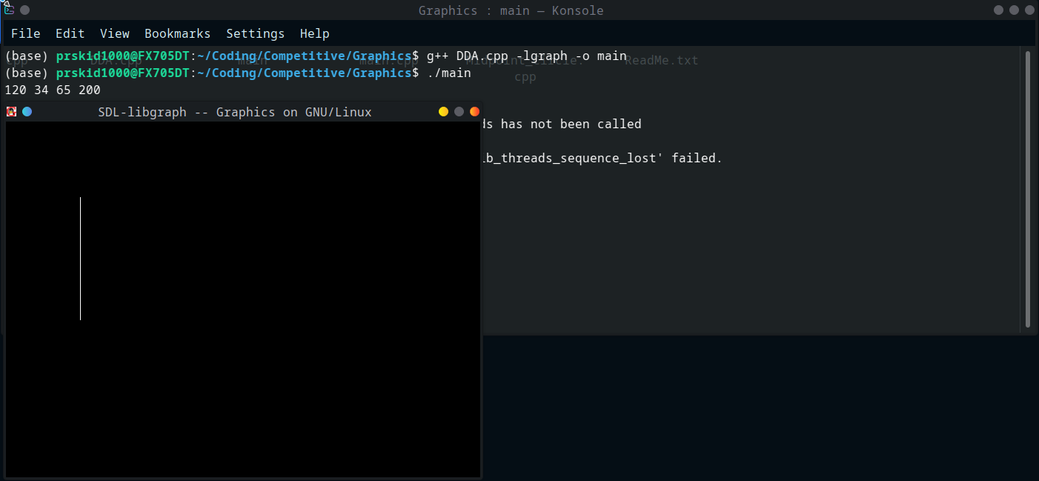

***EXPERIMENT NO.2***

**Aim**

Draw a line using Bresenham’s algorithm

**Theory**

Let’s define f(x,y) = 0 = ax + by +c

D = f(x0 + 1, y0 + 0.5) – f(x0,y­o)D

If D > 0 choose (x0 + 1, y0) and del(D) = del(y)

If D > 0 choose (x0 + 1,y0 + 1) and del(D) = del(y) – del(x)

One performance issue is the ​1⁄2 factor in the initial value of D. Since all of this is about the sign of the accumulated difference, then everything can be multiplied by 2 with no consequence

**Program**

#include<bits/stdc++.h>

#include<graphics.h>

#define ll long long int

using namespace std;

int main()

{

int gd = DETECT, gm, tmp = 0;

ll x1 = 0, x2 = 0, y1 = 0, y2 = 0, dx = 0, dy = 0, p;

cin >> x1 >> y1;

cin >> x2 >> y2;

dx = x2 - x1;

dy = y2 - y1;

//declare all variables before it

initgraph(&gd,&gm, NULL);

//draw here

if(dy > dx)

{

p = 2*(dy - dx);

for(; x1 <= x2; x1++)

{

if(p < 0)

{

p = p + 2 * dy;

}

else

{

y1++;

p = p + 2 * dy - dx;

}

putpixel(100 + x1, 100 + y1, 15);

delay(300);

}

}

else

{

p = 2*(dx - dy);

for(; y1 <= y2; y1++)

{

if(p < 0)

{

p = p + 2 * dx;

}

else

{

x1++;

p = p + 2 * dx - dy;

}

putpixel(100 + x1, 100 + y1, 15);

delay(300);

}

}

//draw ends

getche();

closegraph();

return 0;

}

**Output**

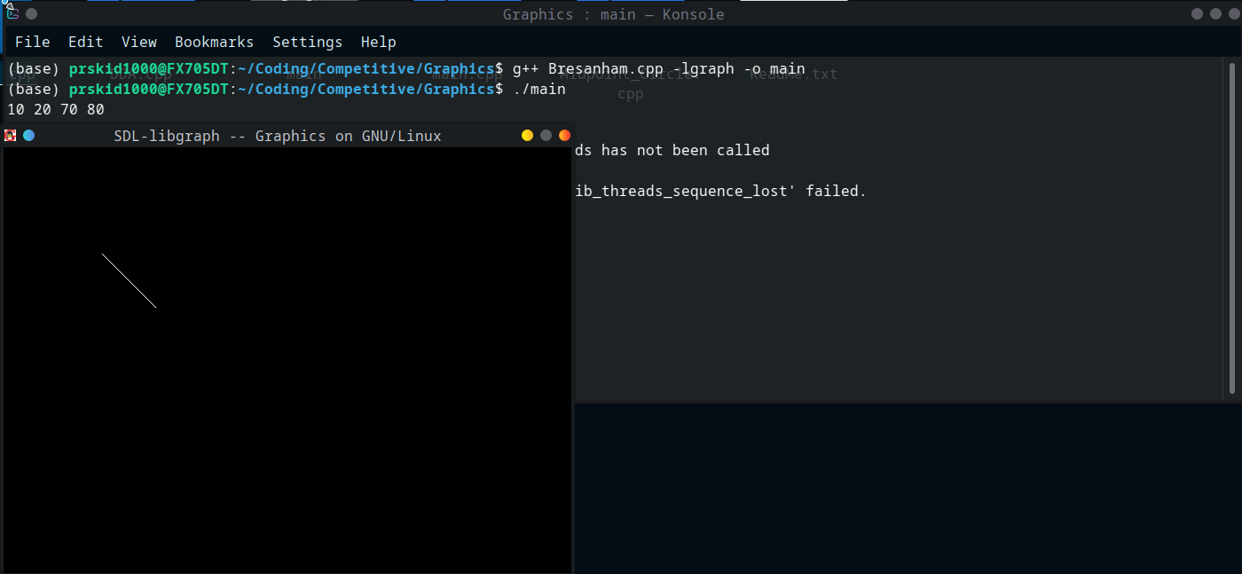

***EXPERIMENT NO.3***

**Aim**

Draw a circle using midpoint algorithm.

**Theory**

The function of a circle i.e.: fcircle(x,y)= x2 +y2 - r2

* If fcircle < 0 then x, y is inside the circle boundary.
* If fcircle > 0 then x, y is outside the circle boundary.
* If fcircle = 0 then x, y is on the circle boundary.

pk =fcircle(xk+1,yk-1/2) where pk is a decision parameter and in this ½ is taken because it is a midpoint value through which it is easy to calculate value of yk and yk-1. i.e. pk= (xk+1)2+ (yk-1/2)2-r2

If pk <0 then midpoint is inside the circle in this condition we select y is yk otherwise we will select next y as yk-1 for the condition of pk > 0.

If pk < 0 then yk+1=yk, by this the plotting points will be ( xk+1 ,yk). By this the value for the next point will be given as: Pk+1=pk +2(xk+1) +1

If pk > 0 then yk+1=yk-1, by this the plotting points will be (xk+1, yk-1). By this the value of the next point will be given as: Pk+1=pk+2(xk+1) +1-2(yk+1)

P0 = fcircle (1, r-1/2)

This is taken because of (x0, y0) = (0, r)

i.e. p0 =5/4-r or 1-r, (1-r will be taken if r is integer)

**Program**

#include<bits/stdc++.h>

#include<graphics.h>

#define ll long long int

#define ld long double

using namespace std;

int main()

{

int gd = DETECT, gm, tmp = 0;

ld r = 0;

cin >> r;

ld x = 0, y = r, d = 1.25 - r;

//declare all variables before it

initgraph(&gd,&gm, NULL);

//draw here

do

{

putpixel(100 + x, 100 + y, 15);

putpixel(100 - x, 100 - y, 15);

putpixel(100 - x, 100 + y, 15);

putpixel(100 + x, 100 - y, 15);

putpixel(100 + y, 100 + x, 15);

putpixel(100 - y, 100 - x, 15);

putpixel(100 - y, 100 + x, 15);

putpixel(100 + y, 100 - x, 15);

if(d < 0)

{

x = x + 1;

y = y;

d = d + 2 * x + 1;

}

else

{

x = x + 1;

y = y - 1;

d = d + 2 * x - 2 * y + 1;

}

delay(300);

}while(x < y);

//draw ends

getche();

closegraph();

return 0;

}

**Output**

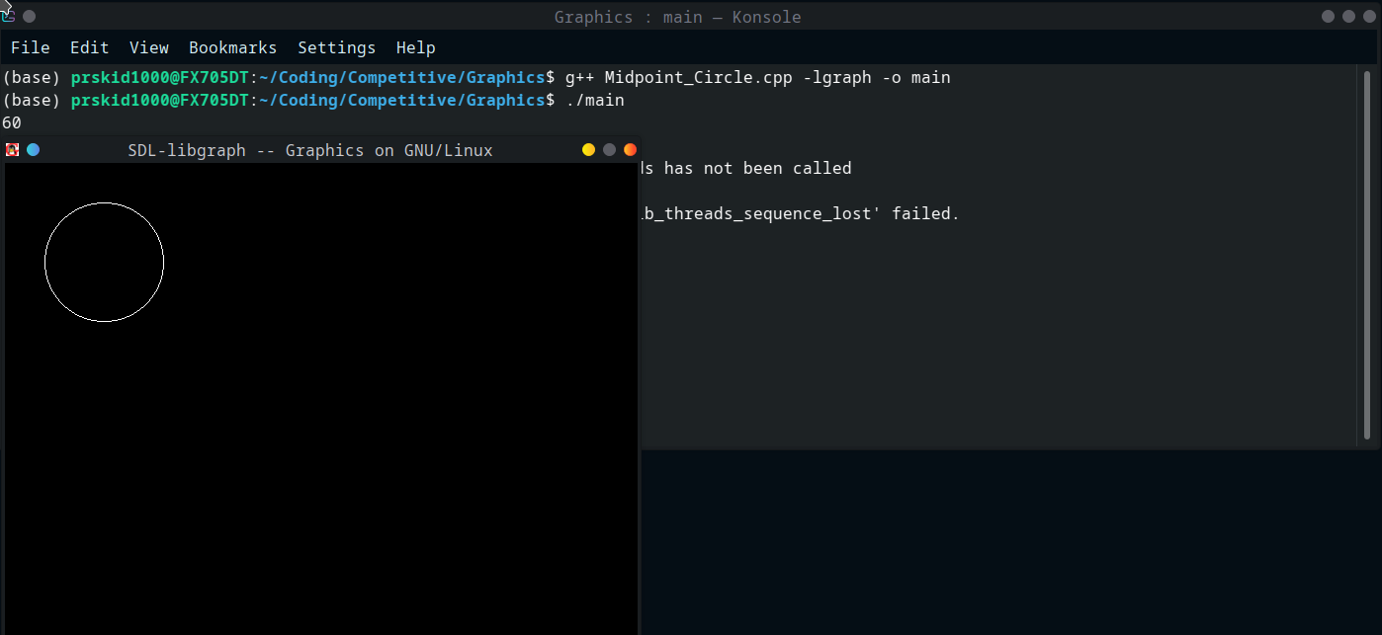

***EXPERIMENT NO.4***

**Aim**

Draw a circle using Bresenham’s algorithm

**Theory**

­We know the equation of the circle is fc(x, y) = x2+ y2 = r2

We assume,

The distance between point P3 and circle boundary = d1

The distance between point P2 and circle boundary = d2

Now, if we select point P3 then circle equation will be

d1= (xk+1)2 + (yk)2– r2

If we select point P2 then circle equation will be-

d2= (xk+1)2 + (yk–1)2– r2

Now, we will calculate the decision parameter (dk) = d1+ d2

dk= 2(xk+1)2 + (yk)2+ (yk-1)2– 2r2

If   dk< 0 then (xk +1, yk) = (xk1, yk)

If  dk>= 0 then (xk +1, yk) = (xk+1, yk-1)

Now, we will find the next decision parameter (dk+1)

dk+1 = 2(xk+1+1)2 + (yk+1)2+ (yk+1-1)2– 2r2

If dk< 0 then yk+1= yk (We select point P3)

If dk>= 0 then yk+1= yk-1 (We select point P3)

Now, we calculate initial decision parameter (d0)

d0= d1+ d2

d0 =   3 – 2r

**Program**

#include<bits/stdc++.h>

#include<graphics.h>

#define ll long long int

#define ld long double

using namespace std;

int main()

{

int gd = DETECT, gm, tmp = 0;

ld r = 0;

cin >> r;

ld x = 0, y = r, d = 3 - 2 * r;

//declare all variables before it

initgraph(&gd,&gm, NULL);

//draw here

do

{

putpixel(100 + x, 100 + y, 15);

putpixel(100 - x, 100 - y, 15);

putpixel(100 - x, 100 + y, 15);

putpixel(100 + x, 100 - y, 15);

putpixel(100 + y, 100 + x, 15);

putpixel(100 - y, 100 - x, 15);

putpixel(100 - y, 100 + x, 15);

putpixel(100 + y, 100 - x, 15);

if(d < 0)

{

x = x + 1;

y = y;

d = d + 4 * x + 6;

}

else

{

x = x + 1;

y = y - 1;

d = d + 4 * x - 4 * y - 10;

}

delay(300);

}while(x < y);

//draw ends

getche();

closegraph();

return 0;

}

**Output**

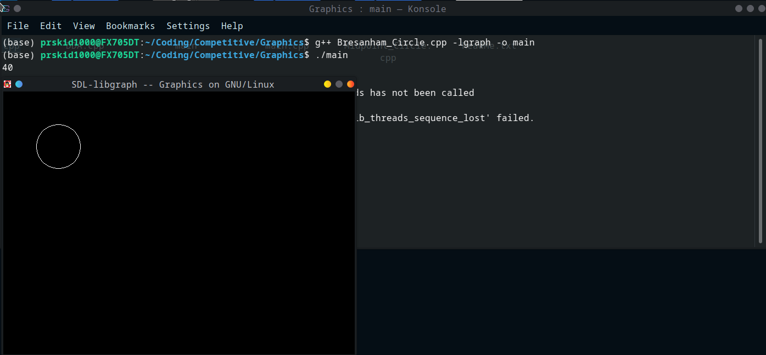

***EXPERIMENT NO.5***

**Aim**

Draw a eclipse using midpoint algorithm.

**Theory**

Take input radius along x axis and y axis and obtain centre of ellipse.

Initially, we assume ellipse to be centred at origin and the first point as : (x, y0)= (0, ry).

Obtain the initial decision parameter for region 1 as: p10=ry2+1/4rx2-rx 2ry

For every xk position in region 1 :

* If p1k<0 then the next point along the is (xk+1, yk) and p1k+1=p1k+2ry2xk+1+ry2
* Else, the next point is (xk+1, yk-1 )  
  And p1k+1=p1k+2ry2xk+1 – 2rx2yk+1+ry2

Obtain the initial value in region 2 using the last point (x0, y0) of region 1 as: p20=ry2(x0+1/2)2+rx2 (y0-1)2-rx2ry2

At each yk in region 2 starting at k =0 perform the following task.

* If p2k>0 the next point is (xk, yk-1) and p2k+1=p2k-2rx2yk+1+rx2
* Else, the next point is (xk+1, yk -1) and p2k+1=p2k+2ry2xk+1 -2rx2yk+1+rx2

Now obtain the symmetric points in the three quadrants and plot the coordinate value as: x=x+xc, y=y+yc

Repeat the steps for region 1 until 2ry2x&gt=2rx2y

**Program**

#include<bits/stdc++.h>  
#include<graphics.h>  
#define ll long long int  
#define ld long double  
using namespace std;  
  
int main()  
{  
    int gd = DETECT, gm, tmp = 0;  
  
    ld dx, dy, d1, d2, x = 0, y, rx, ry, xc, yc;  
    cin >> rx >> ry >> xc >> yc;  
    y = ry;  
  
    //declare all variables before it  
    initgraph(&gd,&gm, NULL);  
    //draw here  
  
  
    d1 = (ry * ry) - (rx * rx * ry) + (0.25 * rx * rx);  
    dx = 2 * ry * ry * x;  
    dy = 2 * rx * rx * y;  
  
    while (dx < dy)  
    {  
      putpixel(100 + x + xc, 100 + y + yc, 15);  
      putpixel(100 - x + xc, 100 + y + yc, 15);  
      putpixel(100 + x + xc, 100 - y + yc, 15);  
      putpixel(100 - x + xc, 100 - y + yc, 15);  
  
  
      if (d1 < 0)  
      {  
        x++;  
        dx = dx + (2 * ry * ry);  
        d1 = d1 + dx + (ry * ry);  
      }  
      else  
      {  
        x++;  
        y--;  
        dx = dx + (2 * ry * ry);  
        dy = dy - (2 * rx * rx);  
        d1 = d1 + dx - dy + (ry * ry);  
      }  
      delay(300);  
    }  
  
    d2 = ((ry * ry) * ((x + 0.5) * (x + 0.5))) +  ((rx * rx) * ((y - 1) * (y - 1))) - (rx * rx * ry * ry);  
  
    while (y >= 0)  
    {  
  
      putpixel(100 + x + xc, 100 + y + yc, 15);  
      putpixel(100 - x + xc, 100 + y + yc, 15);  
      putpixel(100 + x + xc, 100 - y + yc, 15);  
      putpixel(100 - x + xc, 100 - y + yc, 15);  
  
      if (d2 > 0)  
      {  
          y--;  
          dy = dy - (2 * rx * rx);  
          d2 = d2 + (rx * rx) - dy;  
      }  
      else  
      {  
          y--;  
          x++;  
          dx = dx + (2 * ry * ry);  
          dy = dy - (2 * rx * rx);  
          d2 = d2 + dx - dy + (rx * rx);  
      }  
      delay(300);  
    }  
  
    //draw ends  
    getche();  
    closegraph();  
    return 0;  
}

**Output**

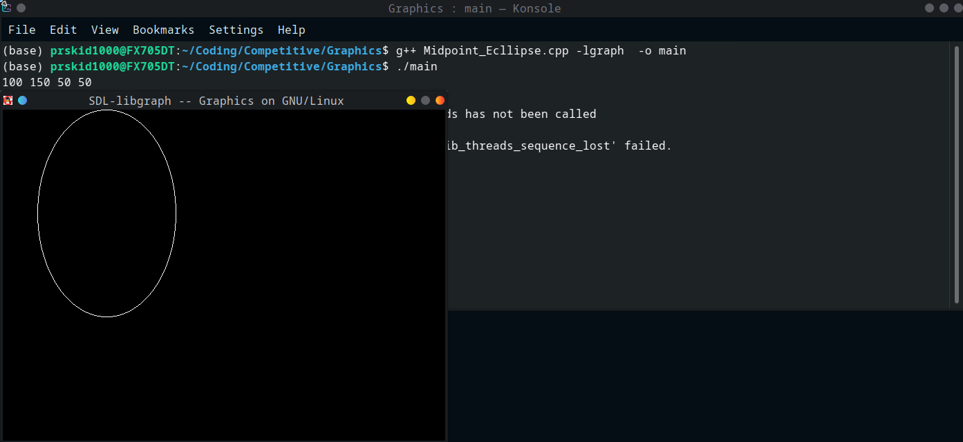

***EXPERIMENT NO.6a***

**Aim**

Draw text using library functions

**Theory**

* **setcolor():** It will set the cursor colour and hence anything written on the output screen will be of the colour as per setcolor().
* **settexttyle():** It set the text font style, its orientation(horizontal/ vertical) and size of font.
* **outtextxy() :** It will print message passed to it at some certain coordinate (x,y).

**Program**

**Note: Program was run in turboc++ inside dosbox**

#include<stdio.h>

#include<graphics.h>

#include<dos.h>

void printMsg()

{

    int gdriver = DETECT,gmode,i;

    initgraph(&gdriver,&gmode,"C:\\TC\\BGI");

    for (i=3; i<7; i++)

    {

        setcolor(i);

        settextstyle(i,0,i);

        outtextxy(100,20*i,"Geeks");

        delay(500);

    }

    delay(2000);

}

int main()

{

    printMsg();

    return 0;

}

**Output**



***EXPERIMENT NO.6b***

**Aim**

Implementing boundary fill algorithm

**Theory**

Boundary Fill Algorithm starts at a pixel inside the polygon to be filled and paints the interior proceeding outwards towards the boundary. This algorithm works only if the color with which the region has to be filled and the color of the boundary of the region are different. If the boundary is of one single color, this approach proceeds outwards pixel by pixel until it hits the boundary of the region.

Boundary Fill Algorithm is recursive in nature. It takes an interior point(x, y), a fill color, and a boundary color as the input. The algorithm starts by checking the color of (x, y). If it’s color is not equal to the fill color and the boundary color, then it is painted with the fill color and the function is called for all the neighbours of (x, y). If a point is found to be of fill color or of boundary color, the function does not call its neighbours and returns. This process continues until all points up to the boundary color for the region have been tested.

The boundary fill algorithm can be implemented by 4-connected pixels or 8-connected pixels.

**Program**

#include<bits/stdc++.h>

#include<graphics.h>

#define ll long long int

#define ld long double

//For outer loop

#define fr(i, start, stop, increment) for(i = start; i < stop; i += increment)

#define dfr(i, start, stop ,decrement) for( i = start; i >= stop; i -= decrement)

using namespace std;

void boundaryFill(ll x, ll y, ll fc, ll bc)

{

if(getpixel(x, y) != bc && getpixel(x, y) != fc)

{

putpixel(x, y, fc);

boundaryFill(x + 1, y, fc, bc);

boundaryFill(x, y + 1, fc, bc);

boundaryFill(x - 1, y, fc, bc);

boundaryFill(x, y - 1, fc, bc);

boundaryFill(x - 1, y - 1, fc, bc);

boundaryFill(x - 1, y + 1, fc, bc);

boundaryFill(x + 1, y - 1, fc, bc);

boundaryFill(x + 1, y + 1, fc, bc);

}

}

int main()

{

int gd = DETECT, gm;

ll n = 0, m = 0, i, j;

cin >> n >> m;

vector<vector<ll>> v(n, vector<ll>(m, 0));

fr(i, 0, n, 1)

{

v[i][0] = 1;

v[i][m - 1] = 1;

}

fr(i, 0, m, 1)

{

v[0][i] = 1;

v[n - 1][i] = 1;

}

//declare all variables before it

initgraph(&gd,&gm, NULL);

//draw here

fr(i, 0, n, 1){

fr(j, 0, m, 1)

{

putpixel(100 + i, 100 + j, v[i][j]);

}

}

boundaryFill(104, 104, 8, 1);

//draw ends

getche();

closegraph();

return 0;

**Output**

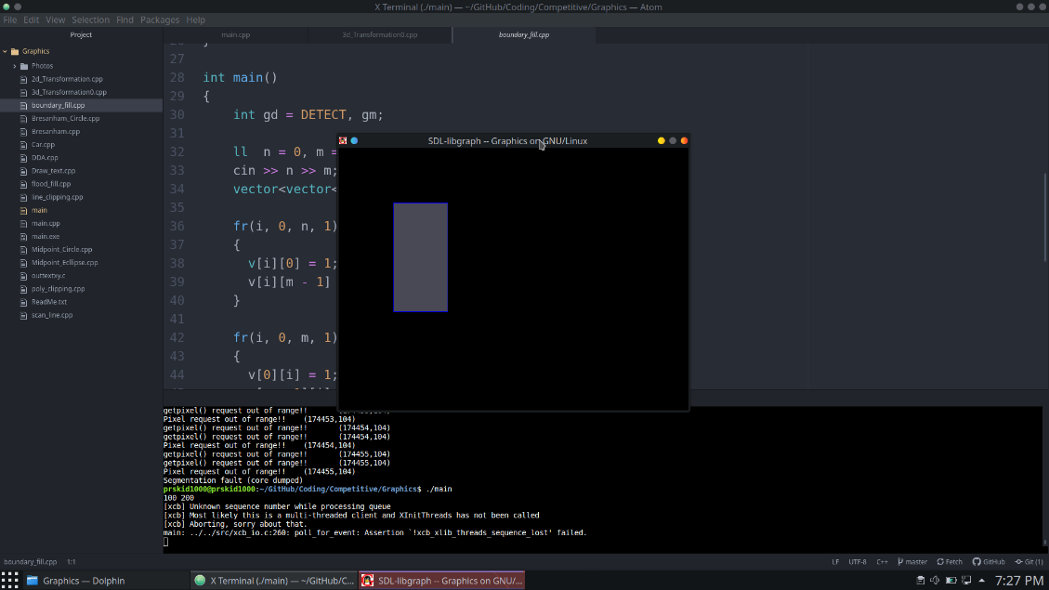

***EXPERIMENT NO.6c***

**Aim**

Implementing flood fill algorithm

**Theory**

* Take the position of the starting point.
* Decide wether you want to go in 4 directions (N, S, W, E) or 8 directions (N, S, W, E, NW, NE, SW, SE).
* Choose a replacement color and a target color.
* Travel in those directions.
* If the tile you land on is a target, reaplce it with the chosen color.
* Repeat 4 and 5 until you’ve been everywhere within the boundaries

**Program**

#include<bits/stdc++.h>

#include<graphics.h>

#define ll long long int

#define ld long double

//For outer loop

#define fr(i, start, stop, increment) for(i = start; i < stop; i += increment)

#define dfr(i, start, stop ,decrement) for( i = start; i >= stop; i -= decrement)

using namespace std;

void floodFillUtil(vector<vector<ll>> &v, ll x, ll y, ll pc, ll nc)

{

if(x < 0 || x >= v.size() || y < 0 || y >= v[0].size()) return;

if(v[x][y] != pc) return;

if(v[x][y] == nc) return;

v[x][y] = nc;

floodFillUtil(v, x+1, y, pc, nc);

floodFillUtil(v, x-1, y, pc, nc);

floodFillUtil(v, x, y+1, pc, nc);

floodFillUtil(v, x, y-1, pc, nc);

}

void floodFill(vector<vector<ll>> &v, ll x, ll y, ll nc)

{

ll pc = v[x][y];

floodFillUtil(v, x, y, pc, nc);

}

int main()

{

int gd = DETECT, gm;

ll n = 0, m = 0, i, j;

cin >> n >> m;

vector<vector<ll>> v(n, vector<ll>(m, 0));

fr(i, 0, n, 1)

{

v[i][0] = 2;

v[i][m - 1] = 3;

}

fr(i, 0, m, 1)

{

v[0][i] = 4;

v[n - 1][i] = 5;

}

//declare all variables before it

initgraph(&gd,&gm, NULL);

//draw here

fr(i, 0, n, 1)

{

fr(j, 0, m, 1)

{

putpixel(100 + i, 100 + j, v[i][j]);

}

}

floodFill(v, 4, 4, 8);

fr(i, 0, n, 1)

{

fr(j, 0, m, 1)

{

putpixel(100 + i, 100 + j, v[i][j]);

}

}

//draw ends

getche();

closegraph();

return 0;

}

**Output**

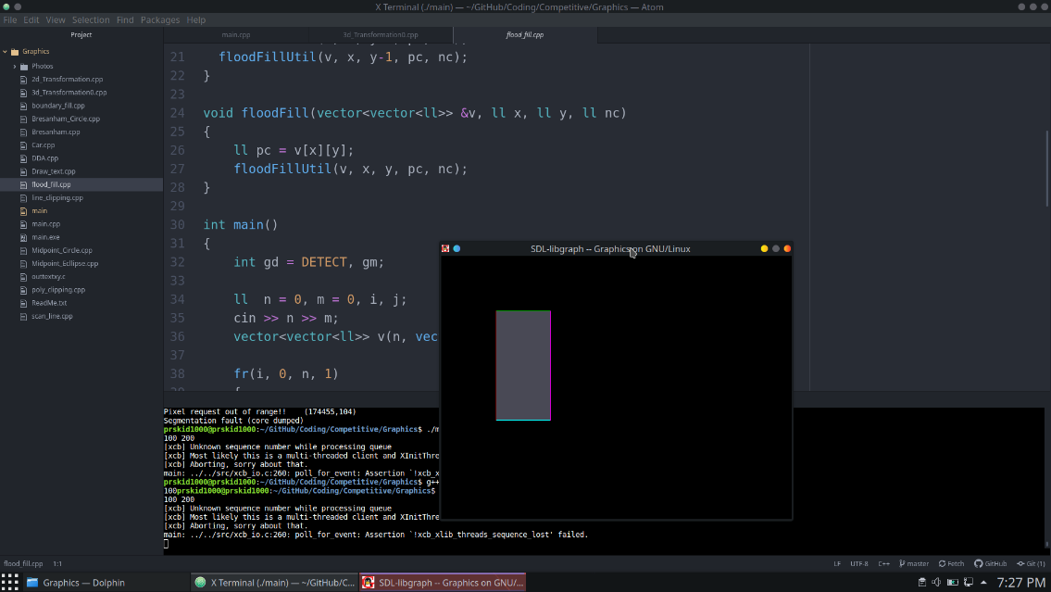

***EXPERIMENT NO.6d***

**Aim**

Implementing scan line algorithm

**Theory**

It is an image space algorithm. It processes one line at a time rather than one pixel at a time. It uses the concept area of coherence. This algorithm records edge list, active edge list. So accurate bookkeeping is necessary. The edge list or edge table contains the coordinate of two endpoints. Active Edge List (AEL) contain edges a given scan line intersects during its sweep. The active edge list (AEL) should be sorted in increasing order of x. The AEL is dynamic, growing and shrinking.

* Start algorithm
* Initialize the desired data structure
* Create a polygon table having color, edge pointers, coefficients. Establish edge table contains information regarding, the endpoint of edges, pointer to polygon, inverse slope.Create Active edge list. This will be sorted in increasing order of x.Create a flag F. It will have two values either on or off.
* Perform the following steps for all scan lines
  + 1. Enter values in Active edge list (AEL) in sorted order using y as value
    2. Scan until the flag, i.e. F is on using a background color.
    3. When one polygon flag is on, and this is for surface S1enter color intensity as I1into refresh buffer
    4. When two or image surface flag are on, sort the surfaces according to depth and use intensity value Sn for the nth surface. This surface will have least z depth value
    5. Use the concept of coherence for remaining planes.
* Stop Algorithm

**Program**

#include <bits/stdc++.h>

#include <graphics.h>

using namespace std;

class point

{

public:

int x,y;

};

class poly

{

private:

point p[20];

int inter[20],x,y;

int v,xmin,ymin,xmax,ymax;

public:

int c;

void read();

void calcs();

void display();

void ints(float);

void sort(int);

};

void poly::read()

{

int i;

cout<<"\n Enter the no of vertices of polygon:";

cin>>v;

if(v>2)

{

for(i=0;i<v; i++)

{

cout<<"\nEnter the co-ordinate no.- "<<i+1<<" : ";

cout<<"\n\tx"<<(i+1)<<"=";

cin>>p[i].x;

cout<<"\n\ty"<<(i+1)<<"=";

cin>>p[i].y;

}

p[i].x=p[0].x;

p[i].y=p[0].y;

xmin=xmax=p[0].x;

ymin=ymax=p[0].y;

}

else

cout<<"\n Enter valid no. of vertices.";

}

void poly::calcs()

{

for(int i=0;i<v;i++)

{

if(xmin>p[i].x)

xmin=p[i].x;

if(xmax<p[i].x)

xmax=p[i].x;

if(ymin>p[i].y)

ymin=p[i].y;

if(ymax<p[i].y)

ymax=p[i].y;

}

}

void poly::display()

{

int ch1;

char ch='y';

float s,s2;

do

{

cout<<"\n\nMENU:";

cout<<"\n\n\t1 . Scan line Fill ";

cout<<"\n\n\t2 . Exit ";

cout<<"\n\nEnter your choice:";

cin>>ch1;

switch(ch1)

{

case 1:

s=ymin+0.01;

delay(100);

cleardevice();

while(s<=ymax)

{

ints(s);

sort(s);

s++;

}

break;

case 2:

exit(0);

}

cout<<"Do you want to continue?: ";

cin>>ch;

}while(ch=='y' || ch=='Y');

}

void poly::ints(float z)

{

int x1,x2,y1,y2,temp;

c=0;

for(int i=0;i<v;i++)

{

x1=p[i].x;

y1=p[i].y;

x2=p[i+1].x;

y2=p[i+1].y;

if(y2<y1)

{

temp=x1;

x1=x2;

x2=temp;

temp=y1;

y1=y2;

y2=temp;

}

if(z<=y2&&z>=y1)

{

if((y1-y2)==0)

x=x1;

else

{

x=((x2-x1)*(z-y1))/(y2-y1);

x=x+x1;

}

if(x<=xmax && x>=xmin)

inter[c++]=x;

}

}

}

void poly::sort(int z)

{

int temp,j,i;

for(i=0;i<v;i++)

{

line(p[i].x,p[i].y,p[i+1].x,p[i+1].y);

}

delay(100);

for(i=0; i<c;i+=2)

{

delay(100);

line(inter[i],z,inter[i+1],z); // Used to fill the polygon ....

}

}

int main()

{

int gd=DETECT,gm;

detectgraph(&gd,&gm);

initgraph(&gd,&gm,NULL);

int cl;

poly x;

x.read();

x.calcs();

cout<<"\n\tEnter the colour u want:(0-15)->"; //Selecting colour

cin>>cl;

setcolor(cl);

x.display();

closegraph();

getch();

return 0;}

**Output**

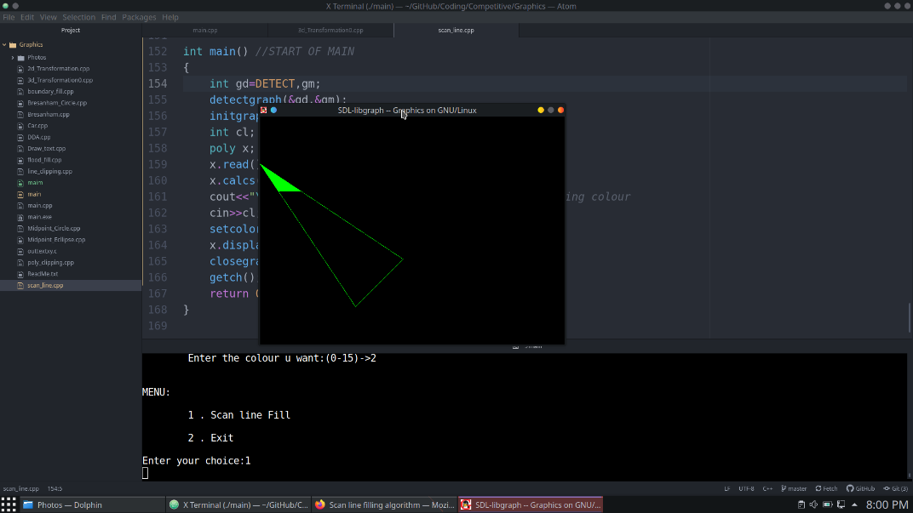

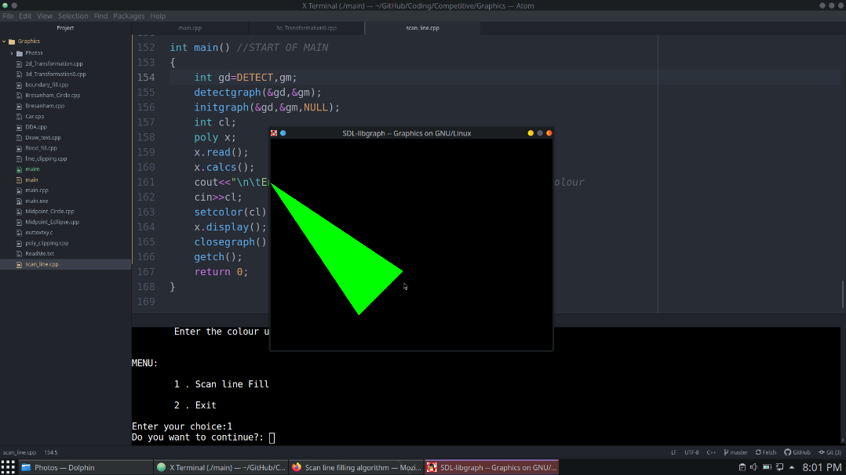

***EXPERIMENT NO.7***

**Aim**

Write a program for performing the basic 2D transformations such as translation, scaling, rotation, shearing and reflection for 2D object.

**Theory**

**Algorithm for scaling**

* For each point P (x, y) do the following

**= x**

* Then finally plot the lines joining those points

**Algorithm for Rotation**

* For each point P (x, y) do the following

**= x**

* Then finally plot the lines joining those points

**Algorithm for Shearing**

* For each point P (x, y) do the following

**= x**

* Then finally plot the lines joining those points

**Algorithm for Reflection**

* For each point P (x, y) do the following

**= x**

* Then finally plot the lines joining those points

**Algorithm for Translation**

* For each point P (x, y) do the following

**= x**

* Then finally plot the lines joining those points

**Program**

Write a program

#include<bits/stdc++.h>

#include<graphics.h>

#define ll long long int

#define ld long double

using namespace std;

void tranlate(float x1, float y1, float x2, float y2, float x3, float y3, float tx, float ty)

{

float mat[3][3] = {{1, 0, tx},{0, 1, ty},{0, 0, 1}};

float pt[3][3] = {{x1, y1, 1},{x2, y2, 1},{x3, y3, 1}};

float npt[3][3] = {{0, 0, 0},{0, 0, 0},{0, 0, 0}};

for(int k = 0; k < 3; k++)

{

for(int i = 0; i < 3; i++)

{

for(int j = 0; j < 3; j++)

{

npt[k][i] += mat[i][j] * pt[k][j];

}

}

}

for(int i = 0; i < 3; i++)

{

line(100 + pt[i][0], 100 + pt[i][1], 100 + pt[(i + 1) % 3][0], 100 + pt[(i + 1) % 3][1]);

}

for(int i = 0; i < 3; i++)

{

line(300 + npt[i][0], 300 + npt[i][1], 300 + npt[(i + 1) % 3][0], 300 + npt[(i + 1) % 3][1]);

}

}

void rotate(float x1, float y1, float x2, float y2, float x3, float y3, float ang)

{

float a = (3.14 * ang) / 180;

float mat[3][3] = {{cos(a), -sin(a), 0}, {sin(a), cos(a), 0}, {0, 0, 1}};

float pt[3][3] = {{x1, y1, 1},{x2, y2, 1},{x3, y3, 1}};

float npt[3][3] = {{0, 0, 0},{0, 0, 0},{0, 0, 0}};

for(int k = 0; k < 3; k++)

{

for(int i = 0; i < 3; i++)

{

for(int j = 0; j < 3; j++)

{

npt[k][i] += mat[i][j] * pt[k][j];

}

}

}

for(int i = 0; i < 3; i++)

{

line(100 + pt[i][0], 100 + pt[i][1], 100 + pt[(i + 1) % 3][0], 100 + pt[(i + 1) % 3][1]);

}

for(int i = 0; i < 3; i++)

{

line(300 + npt[i][0], 300 + npt[i][1], 300 + npt[(i + 1) % 3][0], 300 + npt[(i + 1) % 3][1]);

}

}

void scale(float x1, float y1, float x2, float y2, float x3, float y3, float sx, float sy)

{

float mat[3][3] = {{sx, 0, 0},{0, sy, 0},{0, 0, 1}};

float pt[3][3] = {{x1, y1, 1},{x2, y2, 1},{x3, y3, 1}};

float npt[3][3] = {{0, 0, 0},{0, 0, 0},{0, 0, 0}};

for(int k = 0; k < 3; k++)

{

for(int i = 0; i < 3; i++)

{

for(int j = 0; j < 3; j++)

{

npt[k][i] += mat[i][j] * pt[k][j];

}

}

}

for(int i = 0; i < 3; i++)

{

line(200 + pt[i][0], 200 + pt[i][1], 200 + pt[(i + 1) % 3][0], 200 + pt[(i + 1) % 3][1]);

}

for(int i = 0; i < 3; i++)

{

cout << 100 + npt[i][0] << " " << 100 + npt[i][1] << " " << 100 + npt[(i + 1) % 3][0] << " " << 100 + npt[(i + 1) % 3][1] << "\n";

line(300 + npt[i][0], 300 + npt[i][1], 300 + npt[(i + 1) % 3][0], 300 + npt[(i + 1) % 3][1]);

}

}

void reflect(float x1, float y1, float x2, float y2, float x3, float y3, float rx, float ry)

{

float mat[3][3] = {{rx, 0, 0},{0, ry, 0},{0, 0, 1}};

float pt[3][3] = {{x1, y1, 1},{x2, y2, 1},{x3, y3, 1}};

float npt[3][3] = {{0, 0, 0},{0, 0, 0},{0, 0, 0}};

for(int k = 0; k < 3; k++)

{

for(int i = 0; i < 3; i++)

{

for(int j = 0; j < 3; j++)

{

npt[k][i] += mat[i][j] * pt[k][j];

}

}

}

for(int i = 0; i < 3; i++)

{

line(100 + pt[i][0], 100 + pt[i][1], 100 + pt[(i + 1) % 3][0], 100 + pt[(i + 1) % 3][1]);

}

for(int i = 0; i < 3; i++)

{

line(300 + npt[i][0], 300 + npt[i][1], 300 + npt[(i + 1) % 3][0], 300 + npt[(i + 1) % 3][1]);

}

}

void shear(float x1, float y1, float x2, float y2, float x3, float y3, float sx, float sy)

{

float mat[3][3] = {{1, sx, 0},{sy, 1, 0},{0, 0, 1}};

float pt[3][3] = {{x1, y1, 1},{x2, y2, 1},{x3, y3, 1}};

float npt[3][3] = {{0, 0, 0},{0, 0, 0},{0, 0, 0}};

for(int k = 0; k < 3; k++)

{

for(int i = 0; i < 3; i++)

{

for(int j = 0; j < 3; j++)

{

npt[k][i] += mat[i][j] * pt[k][j];

}

}

}

for(int i = 0; i < 3; i++)

{

line(100 + pt[i][0], 100 + pt[i][1], 100 + pt[(i + 1) % 3][0], 100 + pt[(i + 1) % 3][1]);

}

for(int i = 0; i < 3; i++)

{

line(300 + npt[i][0], 300 + npt[i][1], 300 + npt[(i + 1) % 3][0], 300 + npt[(i + 1) % 3][1]);

}

}

int main()

{

int gd = DETECT, gm, tmp = 0;

cout << "Enter the points = " << "\n";

float x1, y1, x2, y2, x3, y3, sx, sy, rx, ry, tx, ty, ang;

cin >> x1 >> y1 >> x2 >> y2 >> x3 >> y3;

int ch = 0;

cout << "Enter:" << "\n";

cout << "1: Scaling" << "\n";

cout << "2: Rotation" << "\n";

cout << "3: Translation" << "\n";

cout << "4: Shearing" << "\n";

cout << "5: Reflection" << "\n";

cin >> ch;

switch(ch)

{

case 1:

cin >> sx >> sy;

break;

case 2:

cin >> ang;

break;

case 3:

cin >> tx >> ty;

break;

case 4:

cin >> sx >> sy;

break;

case 5:

cin >> rx >> ry;

break;

default:

cout << "Invalid Choice\n";

}

//declare all variables before it

initgraph(&gd,&gm, NULL);

//draw here

switch(ch)

{

case 1:

scale(x1, y1, x2, y2, x3, y3, sx, sy);

break;

case 2:

rotate(x1, y1, x2, y2, x3, y3, ang);

break;

case 3:

tranlate(x1, y1, x2, y2, x3, y3, tx, ty);

break;

case 4:

shear(x1, y1, x2, y2, x3, y3, sx, sy);

break;

case 5:

reflect(x1, y1, x2, y2, x3, y3, rx, ry);

break;

default:

cout << "";

}

//draw ends

getche();

closegraph();

return 0;

}

**Output**

**Scaling**

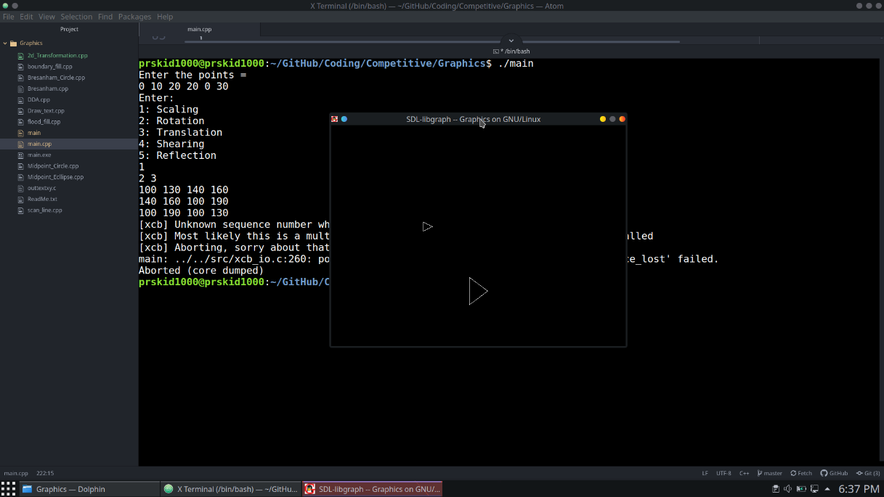

**Shearing**

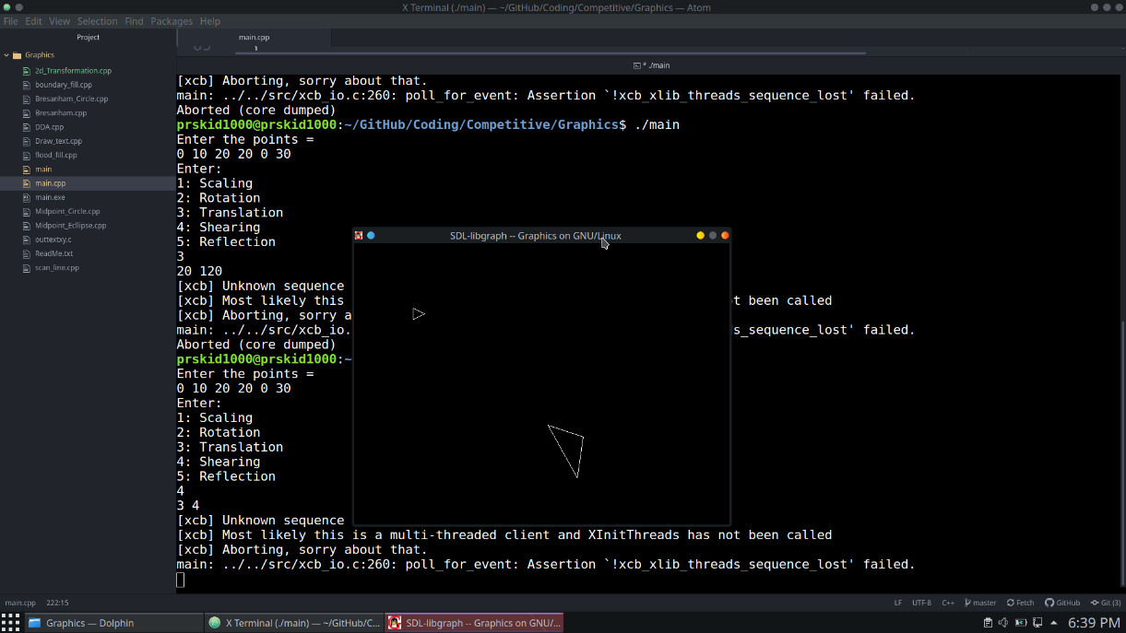

**Translation**

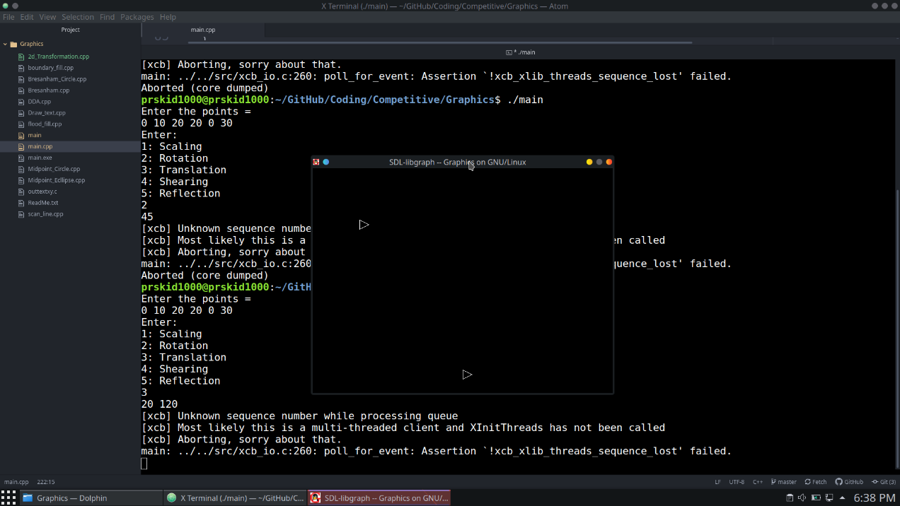

**Reflection**

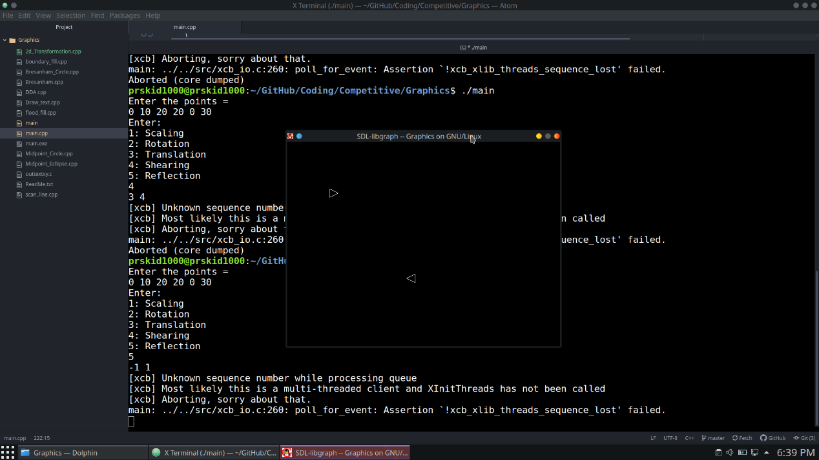

***EXPERIMENT NO.8***

**Aim**

Write a program to create two-dimensional object car as shown in figure.

**Theory**

* Use **line()**, **arc()** and **circle()** function to draw the car

**Program**

#include<bits/stdc++.h>

#include<graphics.h>

#define ll long long int

#define ld long double

using namespace std;

int main()

{

int gd = DETECT, gm, tmp = 0;

//declare all variables before it

initgraph(&gd,&gm, NULL);

//draw here

line(200,50, 300, 50);

line(200, 50, 150, 80);

line(300, 50, 400, 80);

line(100, 80, 450, 80);

line(100, 80, 100, 110);

line(450, 80, 450, 110);

circle(170, 110, 20);

circle(390, 110, 20);

line(100, 110, 150, 110);

line(190, 110, 370, 110);

line(410, 107, 450, 110);

//draw ends

getche();

closegraph();

return 0;

}

**Output**

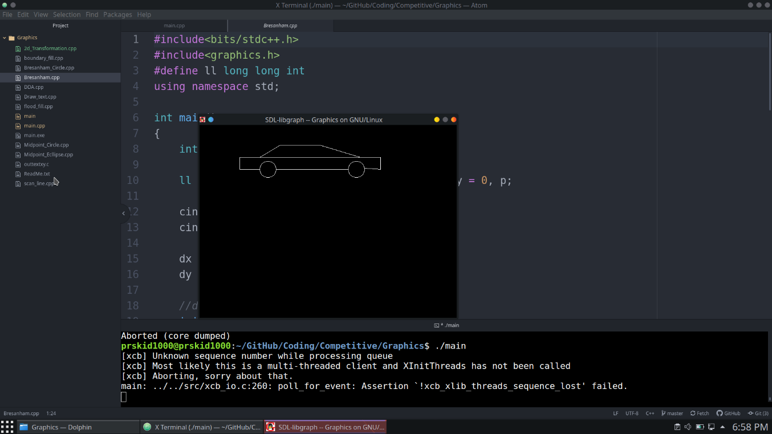

***EXPERIMENT NO.9***

**Aim**

Implementation of Line Clipping using Cohen - Sutherland Algorithm.

**Theory**

Nine regions are created, eight "outside" regions and one

"inside" region.

For a given line extreme point (x, y), we can quickly

find its region's four-bit code. Four-bit code can

be computed by comparing x and y with four values

(x_min, x_max, y_min and y_max).

* If x is less than x_min then bit number 1 is set.
* If x is greater than x_max then bit number 2 is set.
* If y is less than y_min then bit number 3 is set.
* If y is greater than y_max then bit number 4 is set

There are three possible cases for any given line.

* Completely inside the given rectangle: Bitwise OR of region of two end points of line is 0 (Both points are inside the rectangle)
* Completely outside the given rectangle: Both endpoints share at least one outside region which implies that the line does not cross the visible region. (bitwise AND of endpoints! = 0).
* Partially inside the window: Both endpoints are in different regions. In this case, the algorithm finds one of the two points that is outside the rectangular region. The intersection of the line from outside point and rectangular window becomes new corner point and the algorithm repeats



* Assign a region code for two endpoints of given line.
* If both endpoints have a region code 0000

then given line is completely inside.

* Else, perform the logical AND operation for both region codes.

1. If the result is not 0000, then given line is completely

outside.

1. Else line is partially inside.
2. Choose an endpoint of the line that is outside the given rectangle.

Find the intersection point of the

rectangular boundary (based on region code)

Replace endpoint with the intersection

and update the region code.

Repeat step 2 until we find a clipped line either trivially accepted or trivially rejected.

1. Repeat step 1 for other lines

**Program**

#include <bits/stdc++.h>

#include <graphics.h>

using namespace std;

int xmin, xmax, ymin, ymax;

struct lines {

int x1, y1, x2, y2;

};

int sign(int x)

{

if (x > 0)

return 1;

else

return 0;

}

void clip(struct lines mylines)

{

int bits[4], bite[4], i, var;

setcolor(RED);

bits[0] = sign(xmin - mylines.x1);

bite[0] = sign(xmin - mylines.x2);

bits[1] = sign(mylines.x1 - xmax);

bite[1] = sign(mylines.x2 - xmax);

bits[2] = sign(ymin - mylines.y1);

bite[2] = sign(ymin - mylines.y2);

bits[3] = sign(mylines.y1 - ymax);

bite[3] = sign(mylines.y2 - ymax);

string initial = "", end = "", temp = "";

for (i = 0; i < 4; i++) {

if (bits[i] == 0)

initial += '0';

else

initial += '1';

}

for (i = 0; i < 4; i++) {

if (bite[i] == 0)

end += '0';

else

end += '1';

}

float m = (mylines.y2 - mylines.y1) / (float)(mylines.x2 - mylines.x1);

float c = mylines.y1 - m * mylines.x1;

if (initial == end && end == "0000") {

line(mylines.x1, mylines.y1, mylines.x2, mylines.y2);

return;

}

else {

for (i = 0; i < 4; i++) {

int val = (bits[i] & bite[i]);

if (val == 0)

temp += '0';

else

temp += '1';

}

if (temp != "0000")

return;

for (i = 0; i < 4; i++) {

if (bits[i] == bite[i])

continue;

if (i == 0 && bits[i] == 1) {

var = round(m * xmin + c);

mylines.y1 = var;

mylines.x1 = xmin;

}

if (i == 0 && bite[i] == 1) {

var = round(m * xmin + c);

mylines.y2 = var;

mylines.x2 = xmin;

}

if (i == 1 && bits[i] == 1) {

var = round(m * xmax + c);

mylines.y1 = var;

mylines.x1 = xmax;

}

if (i == 1 && bite[i] == 1) {

var = round(m * xmax + c);

mylines.y2 = var;

mylines.x2 = xmax;

}

if (i == 2 && bits[i] == 1) {

var = round((float)(ymin - c) / m);

mylines.y1 = ymin;

mylines.x1 = var;

}

if (i == 2 && bite[i] == 1) {

var = round((float)(ymin - c) / m);

mylines.y2 = ymin;

mylines.x2 = var;

}

if (i == 3 && bits[i] == 1) {

var = round((float)(ymax - c) / m);

mylines.y1 = ymax;

mylines.x1 = var;

}

if (i == 3 && bite[i] == 1) {

var = round((float)(ymax - c) / m);

mylines.y2 = ymax;

mylines.x2 = var;

}

bits[0] = sign(xmin - mylines.x1);

bite[0] = sign(xmin - mylines.x2);

bits[1] = sign(mylines.x1 - xmax);

bite[1] = sign(mylines.x2 - xmax);

bits[2] = sign(ymin - mylines.y1);

bite[2] = sign(ymin - mylines.y2);

bits[3] = sign(mylines.y1 - ymax);

bite[3] = sign(mylines.y2 - ymax);

}

initial = "", end = "";

for (i = 0; i < 4; i++) {

if (bits[i] == 0)

initial += '0';

else

initial += '1';

}

for (i = 0; i < 4; i++) {

if (bite[i] == 0)

end += '0';

else

end += '1';

}

if (initial == end && end == "0000") {

line(mylines.x1, mylines.y1, mylines.x2, mylines.y2);

return;

}

else

return;

}

}

int main()

{

int gd = DETECT, gm;

xmin = 40;

xmax = 100;

ymin = 40;

ymax = 80;

for(int i = 0; i < 4; i++)

{

int x1, y1, x2, y2;

cin >> x1 >> y1 >> x2 >> y2;

mylines[i].x1 = x1;

mylines[i].y1 = y1;

mylines[i].x2 = x2;

mylines[i].y2 = y2;

}

initgraph(&gd, &gm, NULL);

struct lines mylines[4];

line(xmin, ymin, xmax, ymin);

line(xmax, ymin, xmax, ymax);

line(xmax, ymax, xmin, ymax);

line(xmin, ymax, xmin, ymin);

for (int i = 0; i < 4; i++) {

line(mylines[i].x1, mylines[i].y1,

mylines[i].x2, mylines[i].y2);

delay(1000);

}

for (int i = 0; i < 4; i++)

{

clip(mylines[i]);

delay(1000);

}

delay(4000);

getch();

// For Closing the graph.

closegraph();

return 0;

}

**Output**

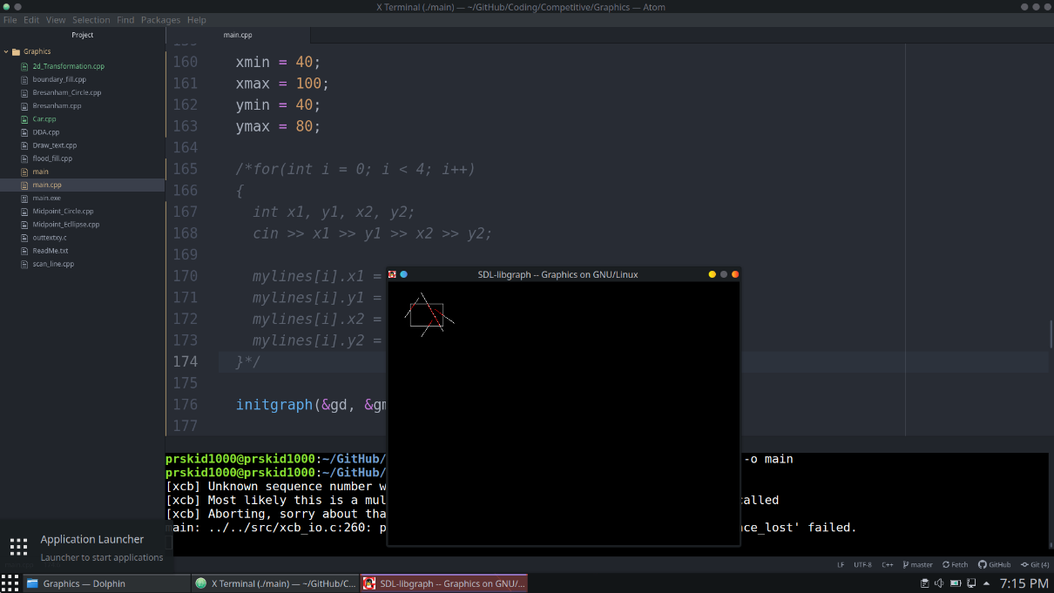

***EXPERIMENT NO.10***

**Aim**

Implementation of Polygon Clipping using Sutherland- Hodgeman Algorithm.

**Theory**

* For each edge e clip the given polygon against e
* The edge (of clipping area) is extended infinitely to create a boundary and all the vertices are clipped using this boundary. The new list of vertices generated is passed to the next edge of the clip polygon in clockwise fashion until all the edges have been used. There are four possible cases for any given edge of given polygon against current clipping edge e.
* **Both vertices are inside:**Only the second vertex is added to the output list
* **First vertex is outside while second one is inside:**Both the point of intersection of the edge with the clip boundary and the second vertex are added to the output list
* **First vertex is inside while second one is outside:**Only the point of intersection of the edge with the clip boundary is added to the output list
* **Both vertices are outside:**No vertices are added to the output list
* If the vertices of the clipper polygon are given in clockwise order then all the points lying on the right side of the clipper edges are inside that polygon. This can be calculated using  
  [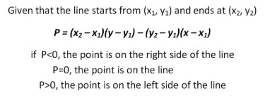](https://media.geeksforgeeks.org/wp-content/uploads/Formula-for-position-of-point.jpg)
* If two points of each line(1,2 & 3,4) are known, then their point of intersection can be calculated using the formula :-  
  [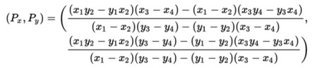](https://media.geeksforgeeks.org/wp-content/uploads/Formula-for-point-of-intersection.jpg)

**Program**

#include <bits/stdc++.h>

#include <graphics.h>

#define TRUE 1

#define FALSE 0

using namespace std;

typedef unsigned int outcode;

outcode CompOutCode(float x,float y);

enum{

TOP = 0x1,

BOTTOM = 0x2,

RIGHT = 0x4,

LEFT = 0x8

};

float xmin,xmax,ymin,ymax;

void clip(float x0,float y0,float x1,float y1)

{

outcode outcode0,outcode1,outcodeOut;

int accept = FALSE,done = FALSE;

outcode0 = CompOutCode(x0,y0);

outcode1 = CompOutCode(x1,y1);

do

{

if(!(outcode0|outcode1))

{

accept = TRUE;

done = TRUE;

}

else

if(outcode0 & outcode1)

done = TRUE;

else

{

float x,y;

outcodeOut = outcode0?outcode0:outcode1;

if(outcodeOut & TOP)

{

x = x0+(x1-x0)*(ymax-y0)/(y1-y0);

y = ymax;

}

else if(outcodeOut & BOTTOM)

{

x = x0+(x1-x0)*(ymin-y0)/(y1-y0);

y = ymin;

}

else if(outcodeOut & RIGHT)

{

y = y0+(y1-y0)*(xmax-x0)/(x1-x0);

x = xmax;

}

else

{

y = y0+(y1-y0)*(xmin-x0)/(x1-x0);

x = xmin;

}

if(outcodeOut==outcode0)

{

x0 = x;

y0 = y;

outcode0 = CompOutCode(x0,y0);

}

else

{

x1 = x;

y1 = y;

outcode1 = CompOutCode(x1,y1);

}

}

}while(done==FALSE);

if(accept)line(x0,y0,x1,y1);

rectangle(xmin,ymin,xmax,ymax);

}

outcode CompOutCode(float x,float y)

{

outcode code = 0;

if(y>ymax)

code|=TOP;

else if(y<ymin)

code|=BOTTOM;

if(x>xmax)

code|=RIGHT;

else if(x<xmin)

code|=LEFT;

return code;

}

int main( )

{

float x1,y1,x2,y2;

int gdriver = DETECT, gmode, n,poly[14],i;

cout << "Enter the no of sides of polygon:";

cin >> n;

cout << "\nEnter the coordinates of polygon\n";

for(i=0;i<2*n;i++)cin >> poly[i];

poly[2*n]=poly[0];

poly[2*n+1]=poly[1];

cout << "Enter the rectangular coordinates of clipping window\n";

cin >> xmin >> ymin >> xmax >> ymax;

initgraph(&gdriver, &gmode, NULL);

drawpoly(n+1,poly);

rectangle(xmin,ymin,xmax,ymax);

delay(5000);

for(i=0;i<n;i++)

{

clip(poly[2*i],poly[(2*i)+1],poly[(2*i)+2],poly[(2*i)+3]);

}

getch( );

closegraph();

return 0;

}

**Output**

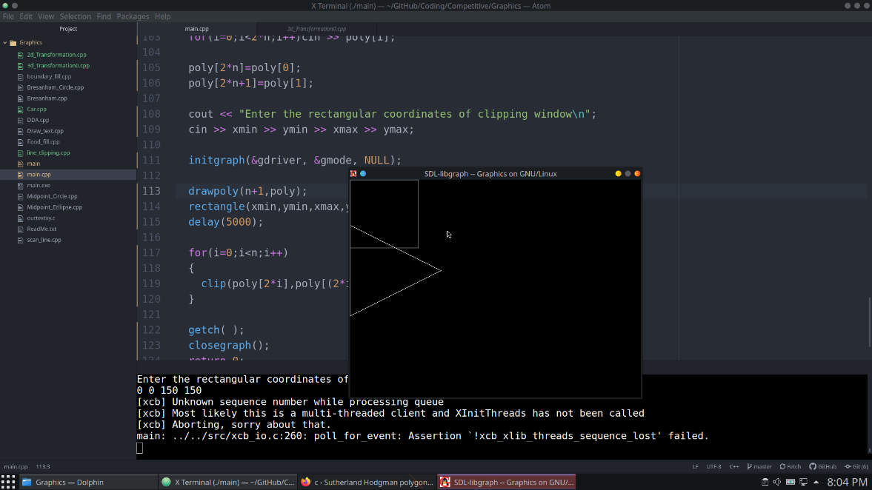

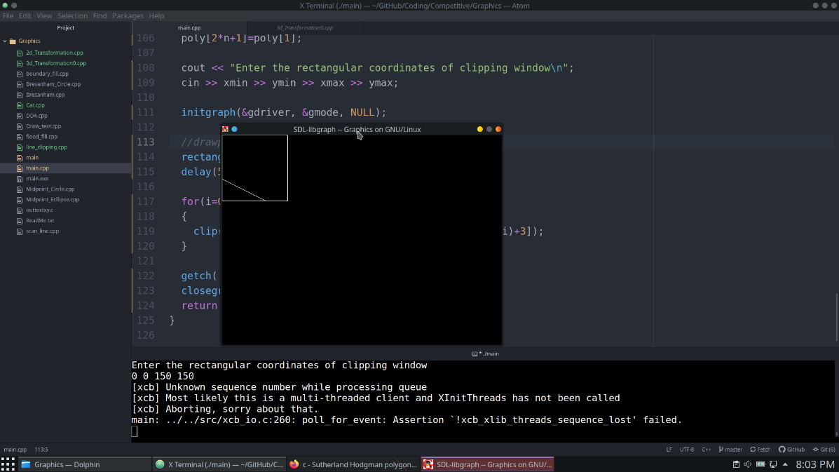

***EXPERIMENT NO.11***

**Aim**

Write a C-program for performing the basic transformations such as Translation, Scaling, Rotation for a given 3D objectt.

**Theory**

**Algorithm for scaling**

* For each point P (x, y, z) do the following
* ***x’ = x * tx***
* ***y’ = y * ty***
* ***z’ = z * tz***
* Then finally plot the lines joining those points

**Algorithm for Rotation**

* For each point P (x, y, z) multiply the Point matrix with Rotation matrix

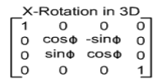 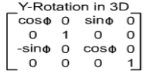 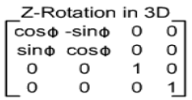

* Then finally plot the lines joining those points

**Algorithm for Translation**

* For each point P (x, y, z) do the following
* ***x’ = x + tx***
* ***y’ = y + ty***
* ***z’ = z + tz***
* Then finally plot the lines joining those points

**Program**

#include<bits/stdc++.h>

#include<graphics.h>

using namespace std;

int maxx,maxy,midx,midy;

void axis()

{

getch();

cleardevice();

line(midx,0,midx,maxy);

line(0,midy,maxx,midy);

}

void translation()

{

int x,y,z,o,x1,x2,y1,y2;

int gd=DETECT,gm;

detectgraph(&gd,&gm);

initgraph(&gd,&gm,NULL);

maxx=getmaxx();

maxy=getmaxy();

midx=maxx/2;

midy=maxy/2;

axis();

bar3d(midx+50,midy-100,midx+60,midy-90,10,1);

cout << "Enter translation factor\n";

cin >> x >> y;

cout << "After translation:\n";

bar3d(midx+x+50,midy-(y+100),midx+x+60,midy-(y+90),10,1);

cin >> x;

closegraph();

}

void scaling()

{

float x,y,z,o,x1,x2,y1,y2;

int gd=DETECT,gm;

detectgraph(&gd,&gm);

initgraph(&gd,&gm,NULL);

maxx=getmaxx();

maxy=getmaxy();

midx=maxx/2;

midy=maxy/2;

axis();

bar3d(midx+50,midy-100,midx+60,midy-90,5,1);

cout << "Enter scaling factors\n";

cin >> x >> y >> z;

cout << "After scaling\n";

bar3d(midx+(x*50),midy-(y*100),midx+(x*60),midy-(y*90),5*z,1);

delay(3000);

cin >> x;

closegraph();

}

void rotation()

{

float x,y,z,o,x1,x2,y1,y2;

int gd=DETECT,gm;

detectgraph(&gd,&gm);

initgraph(&gd,&gm,NULL);

maxx=getmaxx();

maxy=getmaxy();

midx=maxx/2;

midy=maxy/2;

axis();

bar3d(midx+50,midy-100,midx+60,midy-90,5,1);

cout << "Enter rotating angle\n";

cin >> o;

x1=50*cos(o*3.14/180)-100*sin(o*3.14/180);

y1=50*sin(o*3.14/180)+100*cos(o*3.14/180);

x2=60*cos(o*3.14/180)-90*sin(o*3.14/180);

y2=60*sin(o*3.14/180)+90*cos(o*3.14/180);

cout << "After rotation about z axis\n";

bar3d(midx+x1,midy-y1,midx+x2,midy-y2,5,1);

cin >> o;

cout << "After rotation about x axis\n";

bar3d(midx+50,midy-x1,midx+60,midy-x2,5,1);

cin >> o;

cout << "After rotation about yaxis\n";

bar3d(midx+x1,midy-100,midx+x2,midy-90,5,1);

cin >> o;

closegraph();

}

int main()

{

translation();

rotation();

scaling();

return 0;

}

**Output**

**Translation**

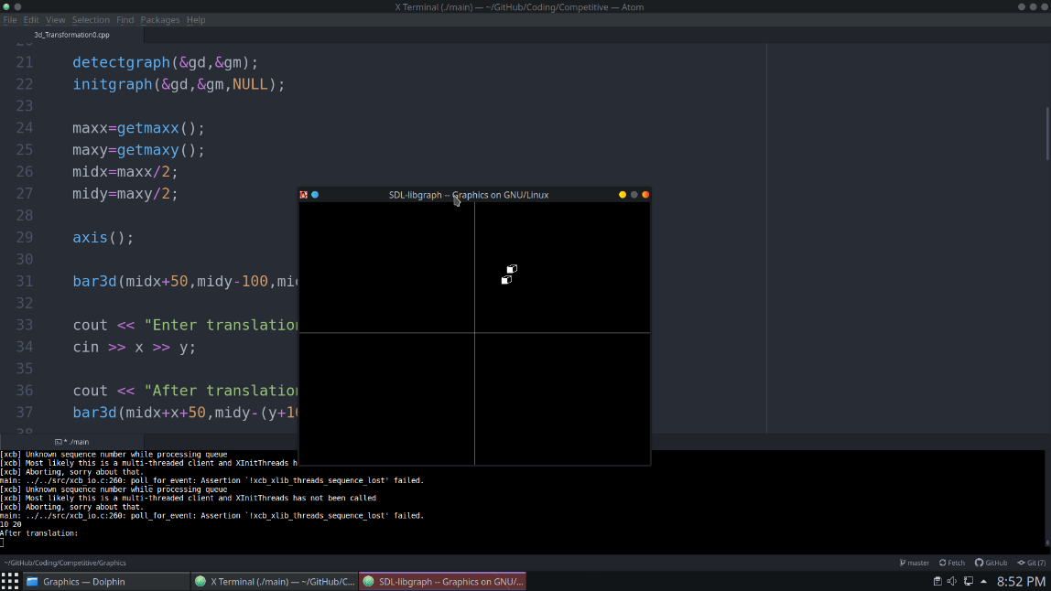

**Scaling**

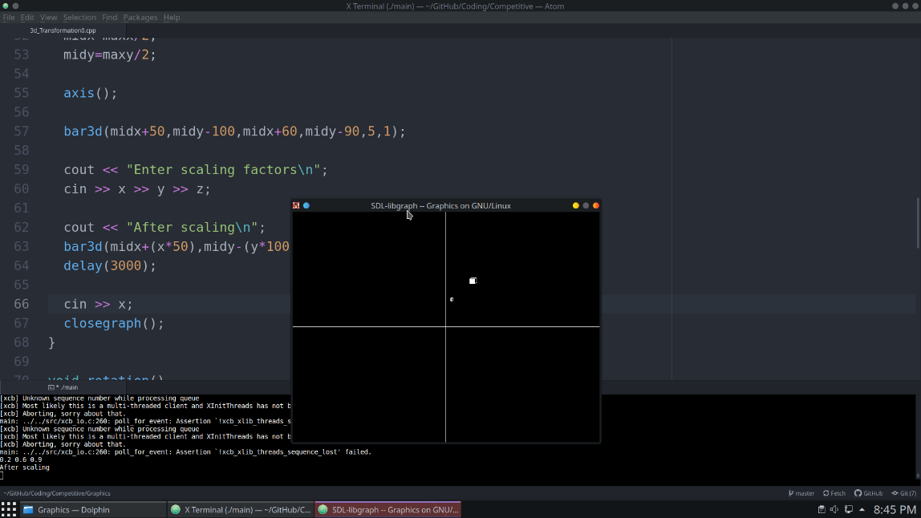

**Rotation**

